36.75: a) 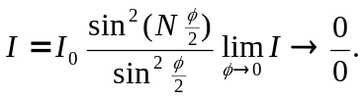
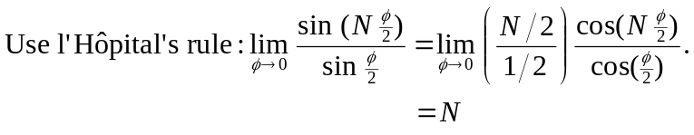
So 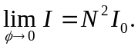
b) The location of the first minimum is when the numerator first goes to zero at 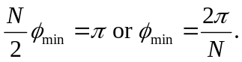The width of the central maximum goes like 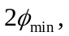 so it is proportional to 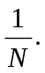
c) Whenever 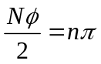where is an integer, the numerator goes to zero, giving a minimum in intensity. That is, is a minimum wherever 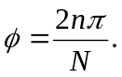 This is true assuming that the denominator doesn’t go to zero as well, which occurs when 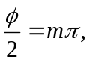where is an integer. When both go to zero, using the result from part(a), there is a maximum. That is, if 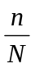is an integer, there will be a maximum.
d) From part c), if is an integer we get a maximum. Thus, there will be 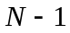minima. (Places where is not an integer for fixed  and integer .) For example, 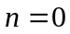 will be a maximum, but 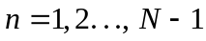 will be minima with another maximum at 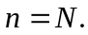
e) Between maxima 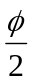 is a half-integer multiple of 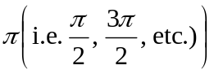 and if is odd then 